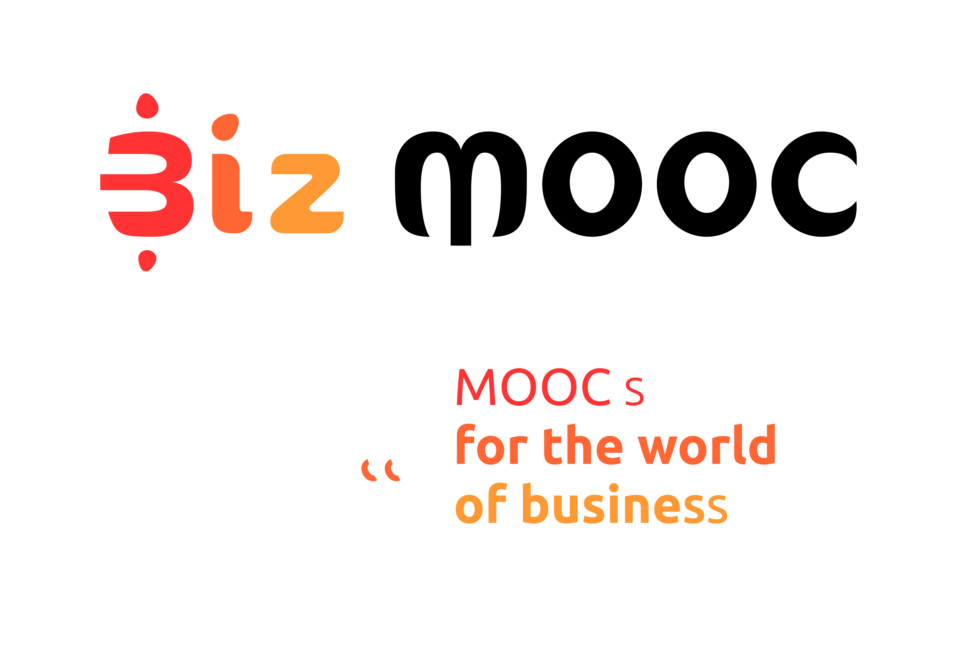
08
Fall

BizMOOC Ressources
Review Template MOOC Design
  - Review Template MOOC Design

BizMOOC Ressources
Review Template MOOC Design

BizMOOC - BizMOOC - Knowledge Alliance to enable a European-wide exploitation of the potential of MOOCs for the world of business
Programme: Erasmus+ | Key Action 2 | Knowledge Alliances
Reference Number: 562286-EPP-1-2015-1-AT-EPPKA2-KA
Grant agreement number: 2015-2929 / 001-001
Project Duration: 36 months, 1/1/2016 – 31/12/2018

www.mooc-book.eu
www.bizmooc.eu

- Form completed to be sent to XXX by XXX

Resources for evaluation
- Design of MOOC according Excel template (You can use the Course Planner by the Open University for this)
- Pilot implementation on Platform (insert link to your MOOC). Please note you will have to sign in and create an account with XXX if you do not have one already. The pilot version is restricted to those who have the password XXX. Enter the password before click on the enrol button for the course.
- Marketing
  - Description on paper (1-2 A4): Insert Course Description
  - Teaser video (Insert marketing materials such as course trailer etc. here)
  - …

Review marketing material
Please provide suggestion how the marketing materials can be improved. Do they provide all necessary elements to inform various target groups? Is it tempting to enrol?

Check if online course meets the MOOC criteria
MOOCs differ from ‘regular’ online courses by various aspects. The list below is to be used to check if the course to be provided is indeed a MOOC. See also MOOC BOOK, Learn More, MOOC areas, chapter 1 About MOOCs

Levels: NA (Not achieved) ; PA (Partially achieved) ; LA (Largely achieved) ; FA (Fully achieved)
Dimension | Criteria | Is it a MOOC or not?
 |  | NA | PA | LA | FA
Massive | The (pedagogical model of the) course is such that the efforts of all services (including of academic staff on tutoring, tests, etc.) does not increase significantly as the number of participants increases.
Open | All people can enrol without limitations
 | At least the course content is always accessible once enrolled
 | Course can be accessed anywhere (location, browser, device, etc.) as long as they have an internet connection
 | No qualifications / diplomas needed to participate in the online course.
 | Full course experience without any costs for participants
Online | All aspects of course are delivered online
Course – study unit | The total study time of a MOOC is minimal 1 ECTS (typically between 1 and 4 ECTS)
Full course | The course offers a full course experience including
 | educational content may include Video – Audio - Text – Games (incl. simulation) – Social Media – Animation
 | offers possibilities for interaction, such as social media channels, forums, blogs or RSS readers
 | participants are provided with some feedback mechanism. Can be automatically generated (e.g., quizzes), only by peers (peer feedback) and/or general feedback from academic staff, etc.
 | always includes some kind of recognition like badges or a certificate of completion. A formal certificate is optional and most likely has to be paid for.
 | study guide / syllabus includes instructions as to how you may learn from the presented materials and interactions.
Levels: NA (Not achieved) ; PA (Partially achieved) ; LA (Largely achieved) ; FA (Fully achieved)

Suggestions to comply to MOOC criteria
Please provide suggestion how the online course can be improved to align more to the MOOC criteria:

Check on quality of the design of MOOC
Dimension | Criteria | Design of MOOC
 |  | NA | PA | LA | FA
Target group
 | For each target group the needs, challenges, prerequisites and prior knowledge are described.
Workload | The schedule of the course is such that the workload per week is feasible for typical learners from target group (typical 6-8 hours for those with full-time jobs)
 | The MOOC is realistic in its pacing for the participant, accommodating to the individuals personal rhythm
Overall goal | The overall objective of the course is described in a few sentences
Learning objectives / outcomes | The course presents a limited number of learning objectives
 | A clear statement of learning outcomes for both knowledge and skills is provided.
 | Learning outcomes align with LLL.
 | There is reasoned coherence between learning outcomes, course content, teaching and learning strategy (including use of media), and assessment methods.
 | The prior knowledge of each learning objective is described and related to characteristics of target groups
Learning activities | Activities aid participants to construct their own learning and to communicate it to others.
 | The "pathways" (activities, tasks and routes) are designed in such a way that they can be performed at different levels of difficulty or complexity, to account for the broad spectrum of participants’ knowledge and skills that is expected.
Various activities are proposed with different formats.
For example: quizzes, peer-to peer evaluation, video conferences (Google+/Hangouts), activities in the forums and platform social networks or external social network (Facebook, Twitter, Goole +)
 | The MOOC contain differing levels of difficulty, with different learning pathways
 | The course contains sufficient interactivity (learner-to-content, learner-to-learner or learner-to-teacher) to encourage active engagement.
Content / assets | A range of assets are used
 | An Asset Log is used to track the licensing, source and creator of any educational / proprietary resources
 | Clear references to any re-used / open licenced resources
 | Open license information for course and each course element is provided
 | Each section is of a similar length and material are consistent in presentation
 | A range of examples is used in the text and any assets (e.g. videos). These should be diverse and not reinforce stereotypes.
Feedback mechanism | Feedback by an academic tutor is limited and scalable (characteristic of MOOC)
 | The course provides learners with regular feedback through self-assessment activities, quizzes, tests or peer feedback.
 | The frequency of monitoring been planned (forum, group, post)
 | A weekly announcements or massive mailing with orientations for the following week is planned
 | In each weekly session, the pedagogical team makes a synthesis of artefacts from the previous week’s session
 | Some live-events (Hangout, Tweetchat) are scheduled
Assessment | Learning outcomes are assessed using a balance of formative and summative assessment appropriate to the level of certification.
 | Assessment is explicit, fair, valid and reliable. Measures appropriate to the level of certification are in place to counter impersonation and plagiarism.
 | Participants can earn a badge/badges for completion of learning activities
 | The MOOC has possibilities to follow the score and progression
Levels: NA (Not achieved) ; PA (Partially achieved) ; LA (Largely achieved) ; FA (Fully achieved)

Suggestions to improve the MOOC
Please provide suggestion how the MOOC can be improved on one or more of the criteria above:

EC / BizMOOC visibility (if part of a EU-funded project)

Dimension | Criteria | EC / BizMOOC
 |  | NA | PA | LA | FA
BizMOOC | Clear connection to the project visible (logo, EU funding disclaimer, link to BizMOOC website etc.)
 | Visual Identidy to BizMOOC in videos
MOOC BOOK | Activities are included which redirects the leaners to the MOOC BOOK and where they have to comment and feedback some content?
 | The introduction videos are subtitled / transcripted
EC | Course (and resources like video) contains the standard EC disclaimer for EC-funded projects
 | Eramus+ logo is used

Accessibility
Dimension | Criteria | Design of MOOC
 |  | NA | PA | LA | FA
Web-accessibility | Compliant to W3C accessibility
 | Compliant to WCAG 2.0 according to EC
Accessible Information | Implemented the Guidelines for Accessible Information
 | The introduction videos are subtitled / transcripted
 | Participants are able to download, store, and use resources without an internet connection
Accessible learning | Implement the Guidelines from Universal Design for Learning
Levels: NA (Not achieved) ; PA (Partially achieved) ; LA (Largely achieved) ; FA (Fully achieved)

Suggestions to improve accessibility of the MOOC
Please provide suggestion how the accessibility of the MOOC can be improved:

